Soen341 Project

Documentation of architectural design

Documentation of architectural design

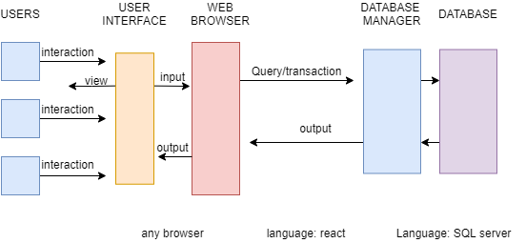

Fig1

The application should be using a SQL server for the data base and React for the user interface and web browser as shown in Fig1. The users would interact with the user interface on the web browser, and if needed

The database should store photos, comments and follow relations.